John Michael Go
Career Entry Level Java Programming
Date: Jan. 17, 2013

DAY 5

Program Name: Exe1

Objective: Program determines if the 2 numbers entered are divisible and not divisible by 5 and 6.

Algorithm:

- User inputs number.
- Program will determine if the 2 numbers entered are divisible and not divisible by 5 and 6.

Flowchart:

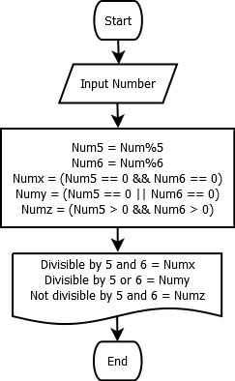

Pseudocode:

import java.util.Scanner;

public class exe1 {

static Scanner console = new Scanner (System.in);

public static void main(String[] args) {

int Num, Num5, Num6;
boolean Numx, Numy, Numz;

System.out.print ("Enter Number: ");
Num = console.nextInt();

Num5 = Num%5;
Num6 = Num%6;
Numx = (Num5 == 0 && Num6 == 0);
Numy = (Num5 == 0 || Num6 == 0);
Numz = (Num5 > 0 && Num6 > 0);

System.out.println( (Num) + " is divisible by 5 and 6 = " + Numx);
System.out.println( (Num) + " is divisible by 5 or 6 = " + Numy);
System.out.println( (Num) + " is neither divisible by 5 and 6 = " + Numz);

}

}

Screenshot:

